 | Generic Risk Assessment Form  Managing Workplace Health and Safety Risks | Form WHS02
For Chemical Risk Assessments, use Myosh or refer to WHS12
For Plant and Equipment Risk Assessments, refer to WHS41
For Fieldwork Risk Assessments refer to Fieldwork Safety
Workplace (Unit/Institute): |  |  |  |  |  |  | Useful links:  - WHS Procedure: Managing Workplace Health and Safety Risks  - Approved Code of Practice: How to Manage Work Health and Safety Risks
Local Assessment No:  If applicable |  | Assessment Date: |  |  | Next Review Date:  (3 years maximum) |  | Sign-off: (by a person with safety responsibility for the risk being assessed, for example: Head of Research Group, Workshop Supervisor, Academic Supervisor, Project Leader, General Manager)  Name: Position: Date: / /
What is being assessed? Describe the item, job, process, work arrangement including the location or facility

People involved in the assessment
Assessor(s):

Others consulted: (eg safety consultant, manager or supervisor, elected health and safety representative, people familiar with the hazards, other personnel exposed to risks)

Refer to Appendix 2 – Risk Assessment Matrix and Risk Priority Table to calculate the level of inherent and residual risk.
Risk assessment |  |  |  |  |  | Risk control plan*
Item | Hazard description/ how exposed  (Refer Appendix 1) |  | Inherent risk level (without controls) | Risk control measure(s) in place  (If existing controls need improvement or new controls introduced, record under the Risk Control Plan columns) | Residual risk level (with controls) | Extra controls needed  to reduce risks to low or very low  (The item should not be used, or the process started until the remaining ‘residual risk’  is L or VL) |  | Person responsible | Date extra controls to be done | Date extra controls completed
1
2
* may be left blank if the current risk level with existing controls in place (‘residual risk’) is low or very low.

Appendix 1 - What hazards might be present?
The purpose of this page is to provide prompts on the types of hazards which might be associated with the item, job process or work arrangement you are assessing.
Hazards are things, situations or arrangements that could potentially cause harm to people, property or the environment. When considering what hazards might be present think about:
- The physical work environment (eg lighting, ergonomics, safe access)
- Equipment, materials and substances used (eg desktop computers, chemicals)
- Work tasks and how they are managed (eg fieldwork, working in isolation, volunteers)
- Work design and management (eg workload, fatigue).

Hazards: Potential to cause harm to people, property or the environment.
General Work Environment |  | Health and Security |  | Plant and equipment
Restricted access or egress |  | Food |  | Vehicles
Confined spaces |  | Poisoning or contamination |  | Mobile and fixed plant
Air-conditioning (thermal comfort) |  | Communicable diseases |  | Powered equipment
Air quality |  | Intoxication |  | Non-powered equipment
Lighting |  | Dehydration |  | Elevated Work Platforms
Noise (discomfort) |  | Violence or assault |  | Pressure vessel
Outdoors (sun exposure) |  | Working alone or in isolation |  | Laser (Class 2 or above)
Uneven walking surfaces |  | Working in remote areas |  | Traffic control
Working at height |  | Bites / Stings |  | Electrical
Ergonomic/manual handling |  | Chemical |  | Vibration
Workstation set up |  | Hazardous chemicals |  | Moving parts
Poor posture |  | Explosives |  | Acoustic / Noise
Lifting / Carrying |  | Engineered nanomaterials |  | Temperature / Weather effects
Pushing / Pulling |  | Gas cylinders |  | Heat
Reaching/overstretching |  | Radiation |  | Cold
Repetitive movement |  | Ionising radiation |  | Rain / Flood
Bending |  | Ultraviolet (UV) radiation |  | Wind
Eye strain |  | Radiofrequency/microwave |  | In or on water
Work design and management |  | Infrared radiation |  | Pressure (Diving / Altitude)
Fatigue |  | Biological |  | Lightning
Workload |  | Microbiological |  | Smoke
Mental stress |  | Animal tissue / Fluids |  | OTHER
Organisational change |  | Human tissue / Fluids
Work violence or bullying |  | Allergenic
Inexperienced or new personnel |  | Other Biological
Volunteer or work experience safety
Children or U18 students

.

Appendix 2 - Risk Assessment Matrix
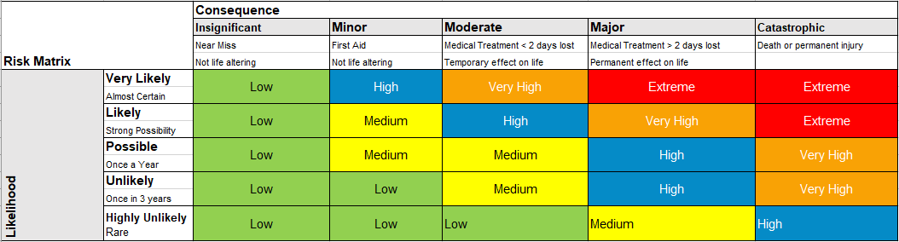

*Based on SafeWork SA risk assessment matrix June 2020

Risk Priority Table

