- Project Details
Project Name:
Project Brief Description:
Project Approval Date: | / / 20 | Approval Source: | COO / PVC / SMG / FC
Business Case: | [Sharepoint Link / Embedded document]
Project Start Date: | / / 20 | Project End Date: | / / 20
Cost Centre: | AD
Project Approved Budget: | $

- Does this project meet the definition and recognition criteria of an Intangible Asset per AASB138.10-21
(Select if true)
- Definition – Identifiability
1a. Is capable of being separated or divided from the entity and sold, transferred, licensed, rented or exchanged, either individually or together with a related contract, identifiable asset or liability, regardless of whether the entity intends to do so; or |  | ☐
1b. Arises from contractual or other legal rights, regardless of whether those rights are transferable or separable from the entity or from other rights and obligations |  | ☐
- Definition – Control
2a. Power to obtain the future economic benefits flowing from the underlying resource (e.g. legal rights); and |  | ☐
2b. To restrict the access of others to those benefits |  | ☐
- Definition – Future Economic Benefits
3a. Existence of future economic benefits such as revenue from sale, cost savings or other benefits |  | ☐
- Recognition Criteria – Future Economic Benefits
4a. It is probable that the expected future economic benefits that are attributable to the asset will flow to the entity that will exist over the useful life of the asset |  | ☐
- Recognition Criteria – Measurement
5a. Cost of the asset can be measured reliably |  | ☐
Have you selected ALL of the above conditions? | Yes ☐  Go to Question 3 | No ☐  Not an Asset

- Please select the most appropriate type of intangible asset (refer to guidance on page 3)
Separately acquired (software/licence) intangible assets on premises (Go to Section 4) | ☐
Internally generated intangible assets on premises (Go to Section 4) | ☐
Cloud computing – Software as a Service (Go to Section 5) | ☐
Cloud computing – Platform as a Service (Go to Section 5) | ☐
Cloud computing – Infrastructure as a Service (Go to Section 5) | ☐

- Software/ Licence
Software/ Licence Name
Software/ Licence Vendor Name
What type of Software/ Licence purchase |  | ☐ Perpetual License  (ie. One-off payment) |  | ☐ Subscription License  (ie. Monthly/Annually)
How is this software/licence being installed and/or configured ¹ |  |  | ☐ Vendor |  | ☐ ISTS |  | ☐ Other
What is the expected life of this software/ licence (usually 5-7 years) |  |  |  |  |  |  |  | years

- Cloud Hosted Services (https://www.pwc.com.au/assurance/ifrs/assets/spotlight-accounting-for-cloud-based-software.pdf)
Service Name
Provider/Host Name
Does UniSA have the right to install software onto UniSA server and restrict access |  |  | ☐ Yes | ☐ No
How is the service being installed and/or configured ¹ |  | ☐ Provider | ☐ ISTS | ☐ Other
Is there internal development and configuration where UniSA owns the intellectual property and can restrict access to the customised service |  |  | ☐ Yes | ☐ No
Does the internal development and configuration create incremental capability and integration ² |  |  | ☐ Yes | ☐ No
What is the agreement term with the service provider |  |  |  | years

¹ Can select more than one if relevant
² Finance may need to get in touch for further clarifications on modifications. Section 5 – Other Comments is also available for any other information.

- Costs
One-off project implementation cost – Software purchase | $
One-off project implementation cost – Configuration and implementation 3rd party | $
One-off project implementation cost – Configuration and implementation ISTS | $
Monthly/Annual – Licence or subscription fee | $
Monthly/Annual – Support Costs | $
Monthly/Annual – Maintenance Costs | $
Total Project Cost | $

- Other Comments

- Project Manager Signoff
Signature |  | Date:
Name (please print): |  | Ext No:
Position title

- Accountant Signoff
Signature |  | Date:
Name (please print): |  | Ext No:
Position title
** Submit form and required attachments (including business case) to Corporate Accounting, Finance Unit **

CAPITAL ACCOUNTANT, FINANCE USE ONLY
Is this an intangible asset | ☐ Yes | ☐ No | Sign: | Date: / / 20
Notes

Type of Intangible Assets Guidance

Separately Acquired (software) intangible assets on premises
Refers to purchase of software applications (off the shelf) from an external provider that is not an integral part of operating a hardware. This includes the cost of acquiring the software, configuring and implementing the software for use.
Internally generated intangible assets on premises
Internally generated software is developed by the University to meet specific business needs when an off the shelf option is not available. Internally generated software is developed in two stages; a research stage and a development stage. Refer to Accounting Policy Framework III – Asset Accounting Framework Section 12 issued by the SA Government Department of Treasury and Finance provides guidance on what costs can be capitalised (included below).
Cloud Computing – Software as a Service (Saas)
Refers to software applications that are delivered over the internet, on demand and usually via subscription. Cloud providers host and manage the software and associated infrastructure, and handle maintenance (i.e. upgrades). Users connect to applications over the internet (via web browser on smart devices or PC). Common examples are business applications such as customer relationship management (CRM), enterprise resource planning (ERP), email, calendaring and office tools (such as Microsoft Office 365).
Cloud Computing – Platform as a Service (Paas)
Refers to cloud computing services that supply an on-demand environment that developers can use to develop, test, deliver and manage software applications. Allows developers to create web or mobile apps without the need to set up or manage the underlying infrastructure (i.e. servers, storage, networks, databases).
Cloud Computing – Infrastructure as a Service (IaaS)
Refers to the most basic group of cloud computing services. Customer pays for scaleable IT infrastructure from a cloud provider on a pay-as-you-go basis. This includes servers, storage, networks and operating systems. Can be a fixed or scaleable capacity.
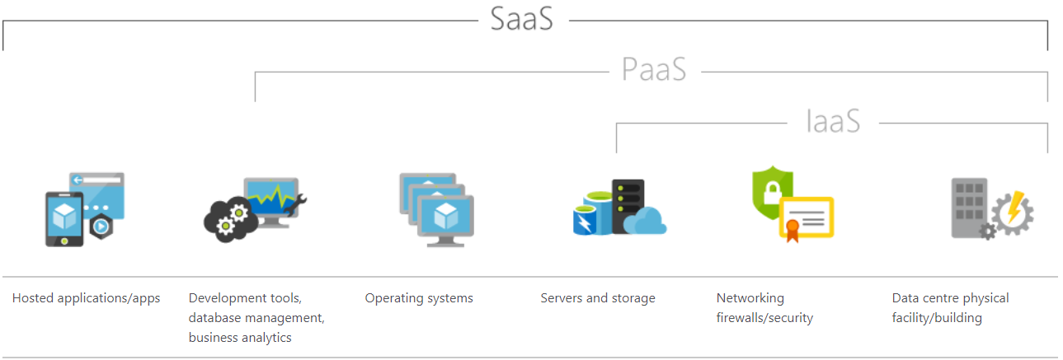

Department of Treasury Finance (DTF)
Accounting Policy Framework III – Asset Accounting Framework Extract
Project Activity/Item | Activity/Cost Item Description | Expenditure Type
1. Initiation Stage (scoping, evaluation and business case) | Project Scoping tasks including,  - Conceptual formulation of alternatives, evaluation of alternatives, determination of the existence of the necessary technology.  - Technology evaluation  - Selection of alternatives  - Business case analysis and the management and planning functions for the project  - Developing standards and architectural designs | Expense
2. Analysis, Design and Development | - Detailed analysis of user requirements  - Detailed design and specification  - Software development configuration and interfaces  - Coding  - Installation of software | Capitalise
3. Testing and Implementation | - Testing up to the point where the system is live  - Implementation of the software | Capitalise
4. Enhancement of existing applications | - Detailed design and specification  - Software configuration  - Development of interfaces  - Coding  - Installation of software  - Testing  - Parallel processing | Capitalise
5. Recurring maintenance and Infrastructure support | - Management costs associated with ensuring the project is completed, including the provision of accommodation, office supplies and corporate services for the project team  - Data conversion from old systems into the new system  - Post implementation review  - Training of staff in the use or administration of the software (training room set up, organising, delivering and attending training, fees paid to vendor to attend a training course)  - Ongoing support and system administration  - Applications maintenance, including maintenance for software licences which includes provision for delivery of software upgrades  - Management of infrastructure resources and cost of infrastructure support  - Minor projects where an asset will be acquired or developed but the total expenditure will not exceed the threshold amount | Expense

